**Name: Arbaaz Iqbal Nakhwa Roll No: 19DCO04**

**Subject: Web Design Lab**

**Class: TECO**

**Exp No**: **9**

**Aim**: Hosting the Website with Domain Registration Process.

**Website link:**

<http://librarysytem.ml/laravel/login.php>

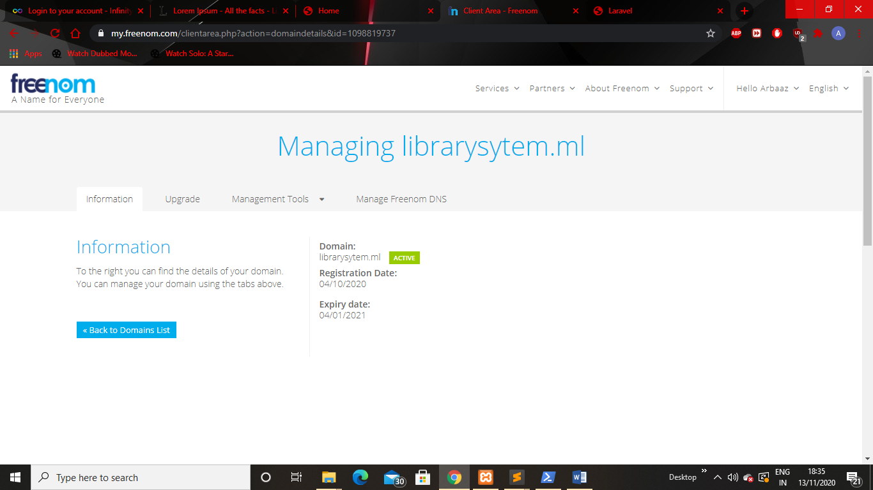

**Fig No.1 Domain Registration**

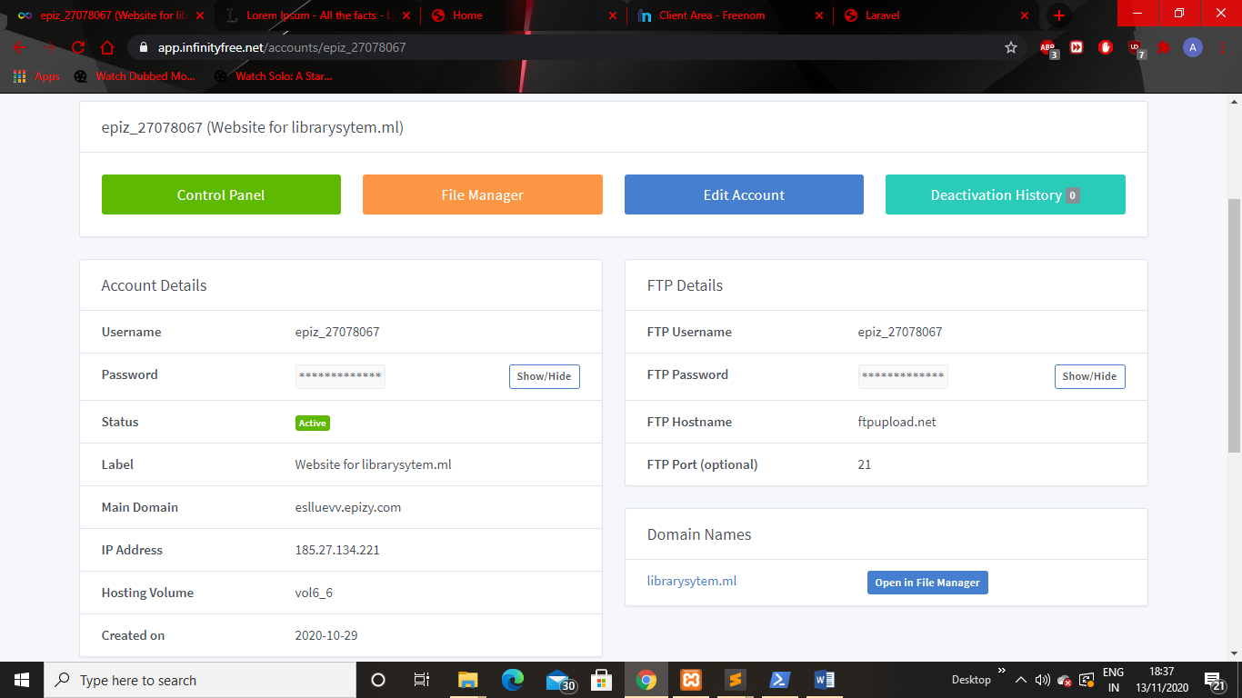

**Fig No.2 Web Hosting Registration**

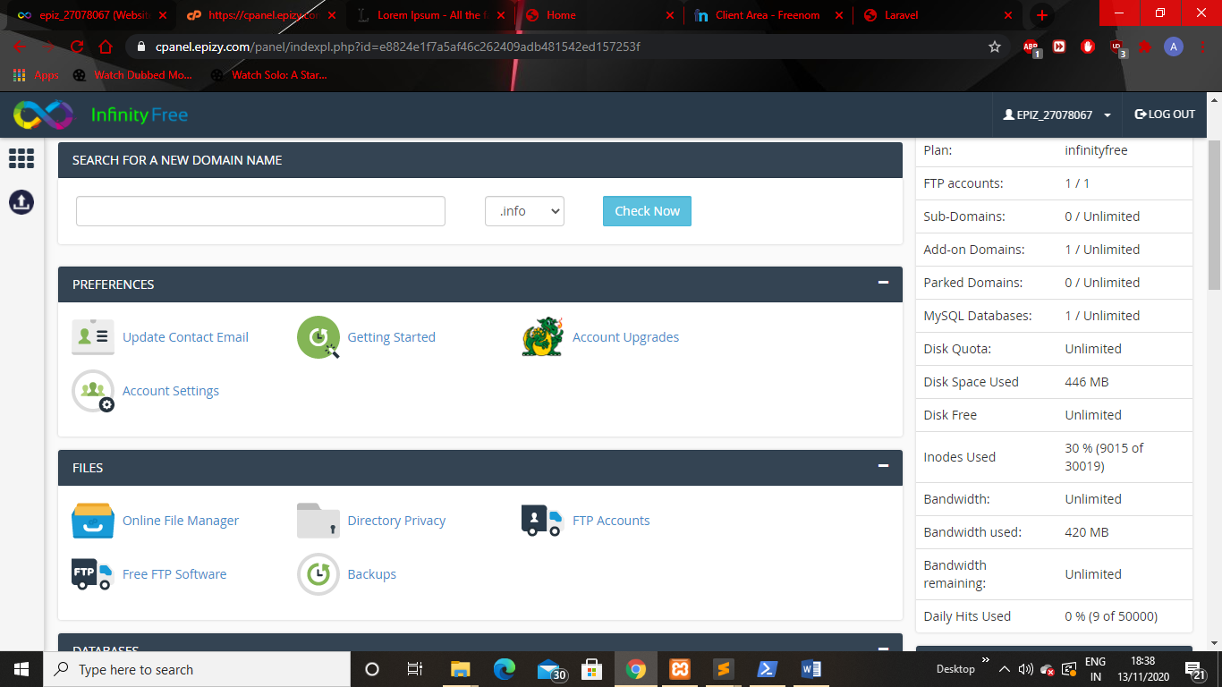

**Fig No.3 Control Panel**

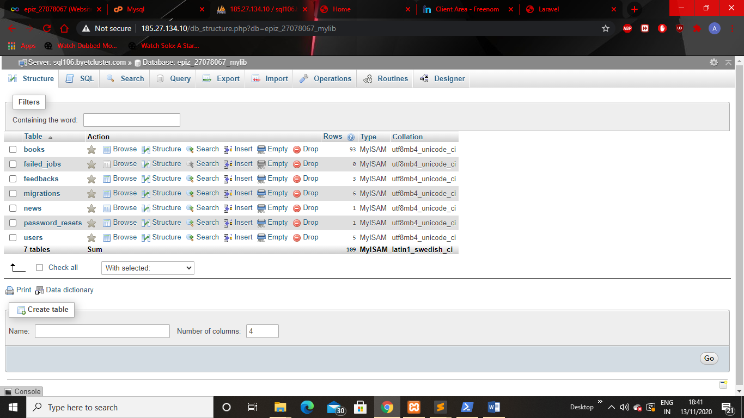

**Fig No.4 MySQL Database**

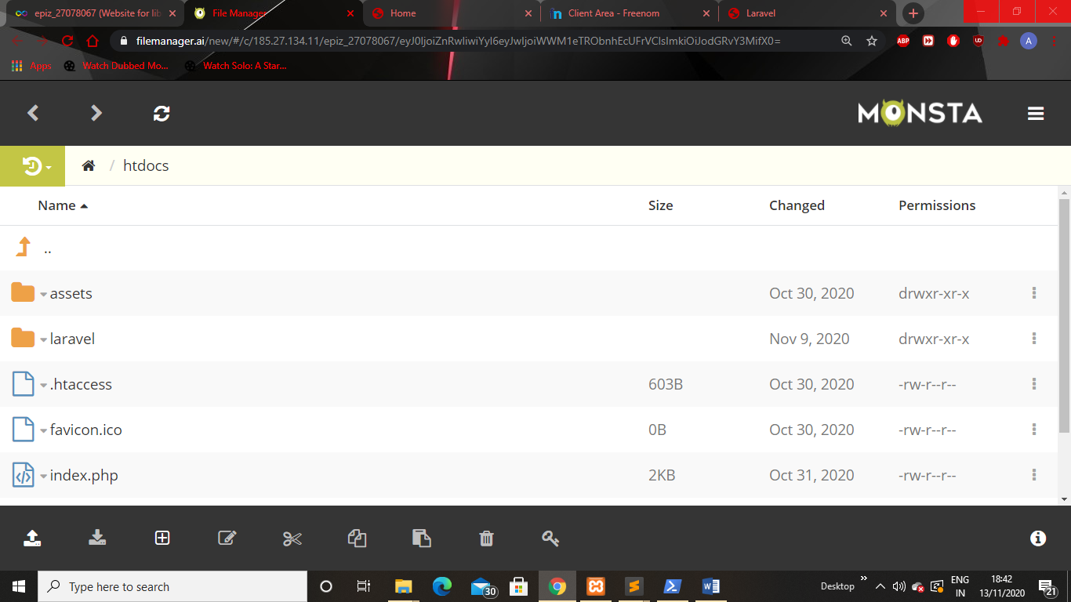

**Fig No.5 File Manager**

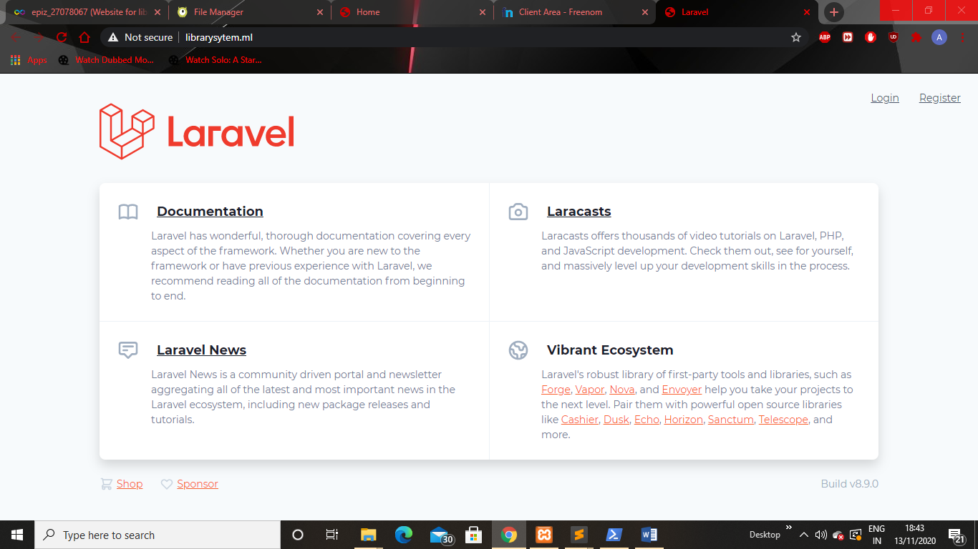

**Fig No.6 Home page of our domain.**

**Conclusion:** Hence,we have understood how to host our website on a particular domain and above are some Screenshots of our hosted website.